**22 October 2024**

**National**

**Inaugural Neil Fettell award winner announced  
at 2024 Agronomy Conference**

Kerry Regan’s dedicated approach to mentoring, supporting, and inspiring the next generation of agronomists and agricultural specialists earns her the honour as inaugural recipient of the Australian Society of Agronomy’s Neil Fettell Award.

From her experience as Executive Officer for the Grains Industry National Research, Development and Extension (RD&E) Strategy through to her current role as Director, Grains, at the Department of Primary Industries and Regional Development, Kerry has been a significant figure in Western Australian grains.

Australian Society of Agronomy President Dr Ben Biddulph said the Society felt it was not only Kerry’s professional excellence that made her the ideal candidate for the award, but also the substantial personal contributions she has made to the development of others in the industry.

“Kerry has demonstrated an outstanding commitment to the agricultural industry,” Dr Biddulph said.

“Like the award’s namesake Neil, Kerry has fostered growth and shared her knowledge selflessly to ensure that our industry continues to thrive. She has been generous in her support of developing and mentoring within her teams and paying it forward to the next generation of agriculturalist.

“Through her dedication, passion, and willingness to nurture others, Kerry embodies the very essence of what this award represents and her imprint on our sector will be felt for generations to come.”

A dedicated agronomist, Dr Neil Fettell was a passionate advocate for research in low-rainfall zones and an inspiring force for positive change in Australian agriculture. His work focused on improving cropping and farming systems and addressing real-world challenges faced by rural communities.

“Neil had remarkable ability to bring people together, whether speaking at field days or presenting scientific papers,” Dr Biddulph said.

“He had a special gift for asking the hard, thoughtful questions that pushed the boundaries of research and encouraged us all to think deeper.

“He was appreciated nationally for his unselfish giving of time, expertise, and support in developing, mentoring and fostering the professional growth of young agronomists across New South Wales, South Australia, Victoria and WA's grain growing regions and it is for this attribute that the Society would like to recognise Neil’s legacy.

“The Society is pleased to recognise Kerry as the inspiring inaugural recipient of the Neil Fettell Award.”

For more information visit the Agronomy Australia website [www.agronomyaustralia.org](http://www.agronomyaustralia.org)

**Contact Details:**

|  |  |
| --- | --- |
| Interviews | Dr Ben Biddulph  President, Australia Society of Agronomy  c/o [office@agronomyaustralia.org.au](mailto:office@agronomyaustralia.org.au)  0428 920 654 |

**More on Neil Fettell Award:**

The Australian Society of Agronomy introduced Neil Fettell Award during 2024 to recognise an individual who has made a lifelong commitment to the agricultural industry. This award is not just about professional excellence, but also about the significant personal contributions these individuals have made to the development of others.

The award is named in honour of the late Neil Fettell, a dedicated agronomist who was a passionate advocate for agricultural research in low-rainfall zones and an inspiring force for positive change in Australian agriculture. His work focused on improving cropping and farming systems and addressing real-world challenges faced by rural communities. Neil was a highly respected leader in applied agronomy, his contributions earning him recognition as the NSW Agriculture Staff Award in 2000 and the GRDC Seed of Light Award in 2002.

**More on the 21st Australian Agronomy Conference:**

The 21st Australian Agronomy Conference, convened by the Australia Society of Agronomy, will be held in Albany, WA, from 21-24 October. The Conference is the premier biennial meeting that brings together industry professionals, researchers, and consultants and growers to discuss latest advancements on agronomy nationally. It serves as a platform for the exchange of knowledge, ideas, and experiences that contribute to the advancement of sustainable agricultural practices.

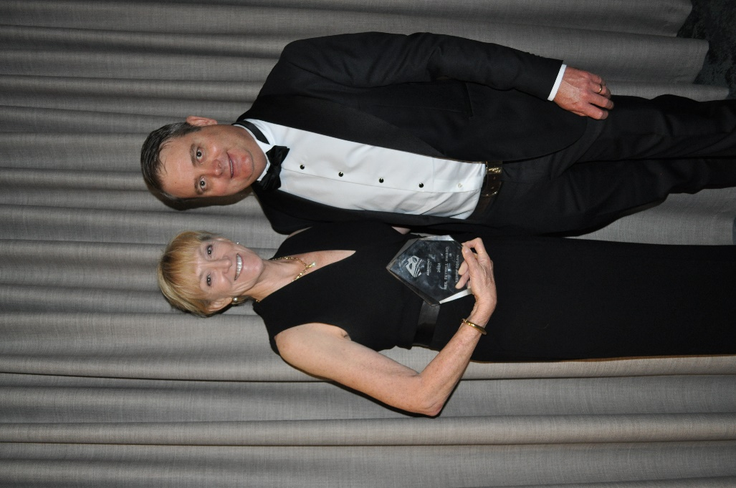

**Picture caption:** *Inaugral Neil Fettell Award winner Kerry Regan, Director, Grains, at the Department of Primary Industries and Regional Development with the President of Agronomy Australia, Dr Ben Biddulph. Photo: Sue Knights*